Central Recruitment Group (CRG)
Fresher Hiring Process
Document Version [1.0] and Date [09.07.2016]
By RC

Purpose
  - To outline the Fresher hiring process at organizational level.
  - Campus and off campus recruitment.
  - Imbibe best practice and learning of previous experiences.

Scope
- To cover on Campus and off Campus hiring for all the functions.

Objectives
  - Standardize and achieve uniformity of hiring for campus and
off campus recruitments.
  - Create and build strong foundation base at the org level.

RELATIONSHIP TO MASTEK VALUES
- Long Term Relationship

The Approach
- Candidates from various colleges shall be called for the interview. (Campus as well as
Off Campus)
  - Campuses that we visit are selected based on set criteria, which includes:
    - The college ranking in survey carried out by reputed organization.
    - Its reputation as an education body
    - History of the performance of its earlier students.
    - The preference it allocates to our organization in providing early slots.
  - Engineering Campuses have been categorized into the following groups:
    - Tier 1 Colleges (All IITs, BITS Palani, IT BHU, IISC i.e All the top 10 colleges in India)
    - Tier 2 Colleges (All NITs, IITs, Government & private top 50 colleges in India)
    - Tier 3 Colleges (Consists of all good regional / City Colleges among the top 100 in India)
    - Tier 4 Colleges (Consists of all other colleges i.e. whose ranking are beyond 100 in India)
- Based on the recruitment plan which is created by the manpower forecast plan based on the inputs from various units and functions across the organization, which specifies the number of fresher to be hired, the number of offer to be made is decided taking into account past data on the joining ratio of the candidates.
- The policy is applicable for all fresher open positions announced by recruitment team only.
- The candidates from Mastek events ( Deep Blue, Buddy Referral) shall be shortlisted by a committee formed by the CoE along with recruitment team.
Criteria / Guideline to be hired:
  - Successful completion of the project.
  - Overall culturally fit to be hired.
- There is an approved list of interviews panels which specifies employees who are eligible to take technical / HR interview.
- All the students (campus + off campus) should have 60% and above in 10th 12th and degree no KT in final Semester or gaps in education. Degree should be BE/ BTech/ MCA/ME/ MBA.
- Aptitude cum Technical Test shall be conducted to evaluate the students on analytical and Mathematical skills and presentation for communication skills.
- Technical / HR round will be conducted for the candidates successfully clearing the written and verbal test to evaluate the overall fitment.
- Entire selection process may take one or more days depending on the number of students appearing for the process.
- Recruitment team communicates the list of selected students once the process is completed.
- The offer letter for the successful candidates is released in the standard template.
- The Recruitment team will remain in touch with the campus and the offered candidates to ensure high joining ratio.
- The overall process success shall be evaluated based on the experiences / learning and recommendations from the CoE along with the leadership team at the end of the recruitment phase and improvement actions shall be taken.

Diagramatic approach
A -- Selection Criteria
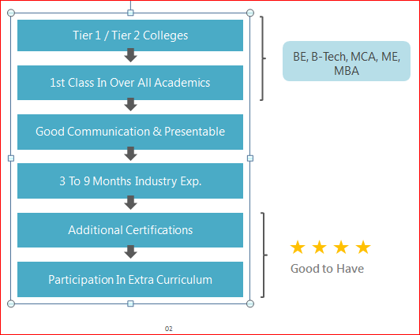

B -- process Flow
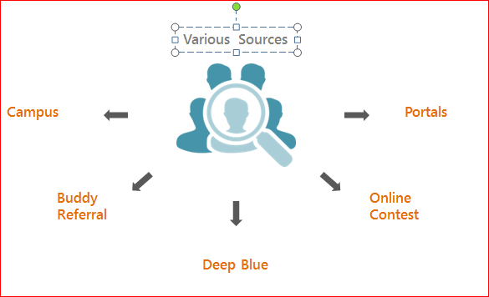

Process Flow
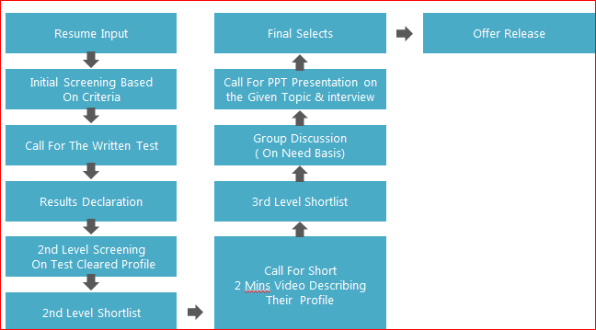

AMENDMENT HISTORY
Version No. | Date | Amendment History | Remarks
1.00 | 9/7/2016 | Final

QMS Document Control Information
Division: OET | Doc No: FM/OET/09 | Version: 2.10

